Practical-10
Secure Login/Logout with Sessions, Role-Based Access, Timeout, and Remember-Me Token
Theory
1. Are sessions started and destroyed securely?
Answer: Yes. PHP starts the secure session, regenerates the session ID after login, and removes session data and the session cookie during logout.
2. Is password_verify() used correctly?
Answer: Yes. The entered password is checked using password_verify() against the password hash saved in the user_accounts table. Incorrect passwords are rejected.
3. Is unauthorized dashboard access blocked?
Answer: Yes. Users must log in before opening protected dashboards. A student attempting to open admin.php receives HTTP 403 Access Denied; after logout, the page redirects to login.
4. Is session timeout implemented?
Answer: The PHP code sets a 900-second (15-minute) inactivity limit and redirects expired sessions to the login page. A completed 15-minute timeout test screenshot was not supplied.
5. Are admin and student users redirected to appropriate dashboards?
Answer: Yes. The student account opens dashboard.php, while the administrator account opens admin.php. Their roles were checked in the database and in the browser.
Result:
Secure authentication was implemented in StudentHub using PHP sessions and MySQL. Student and admin logins, role-based restrictions, failed-login rejection, logout and post-logout protection were demonstrated. A hashed Remember-Me token was stored, and the student dashboard was shown again after the session-cookie test. Timeout expiration and the before/after token-hash change were not independently demonstrated by screenshots.
Evidence of Work (Screenshots)
The following original screenshots document the completed login, access-control, logout and persistent-login tests.

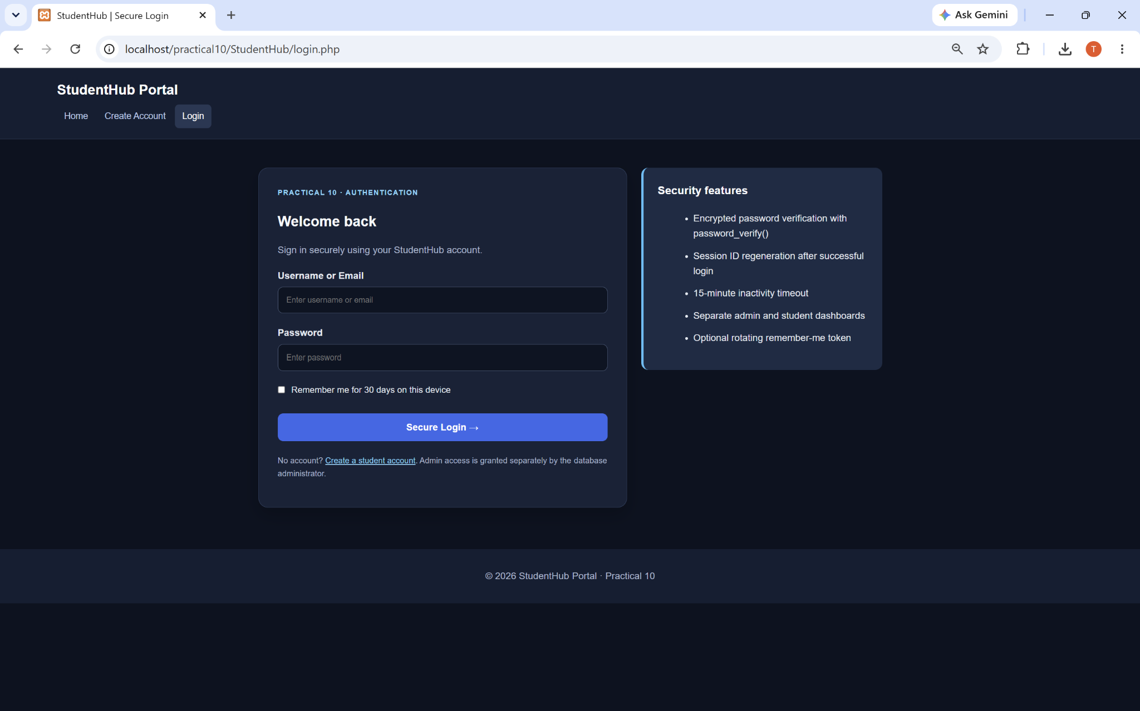
Figure 1: Secure Login Page - StudentHub Portal
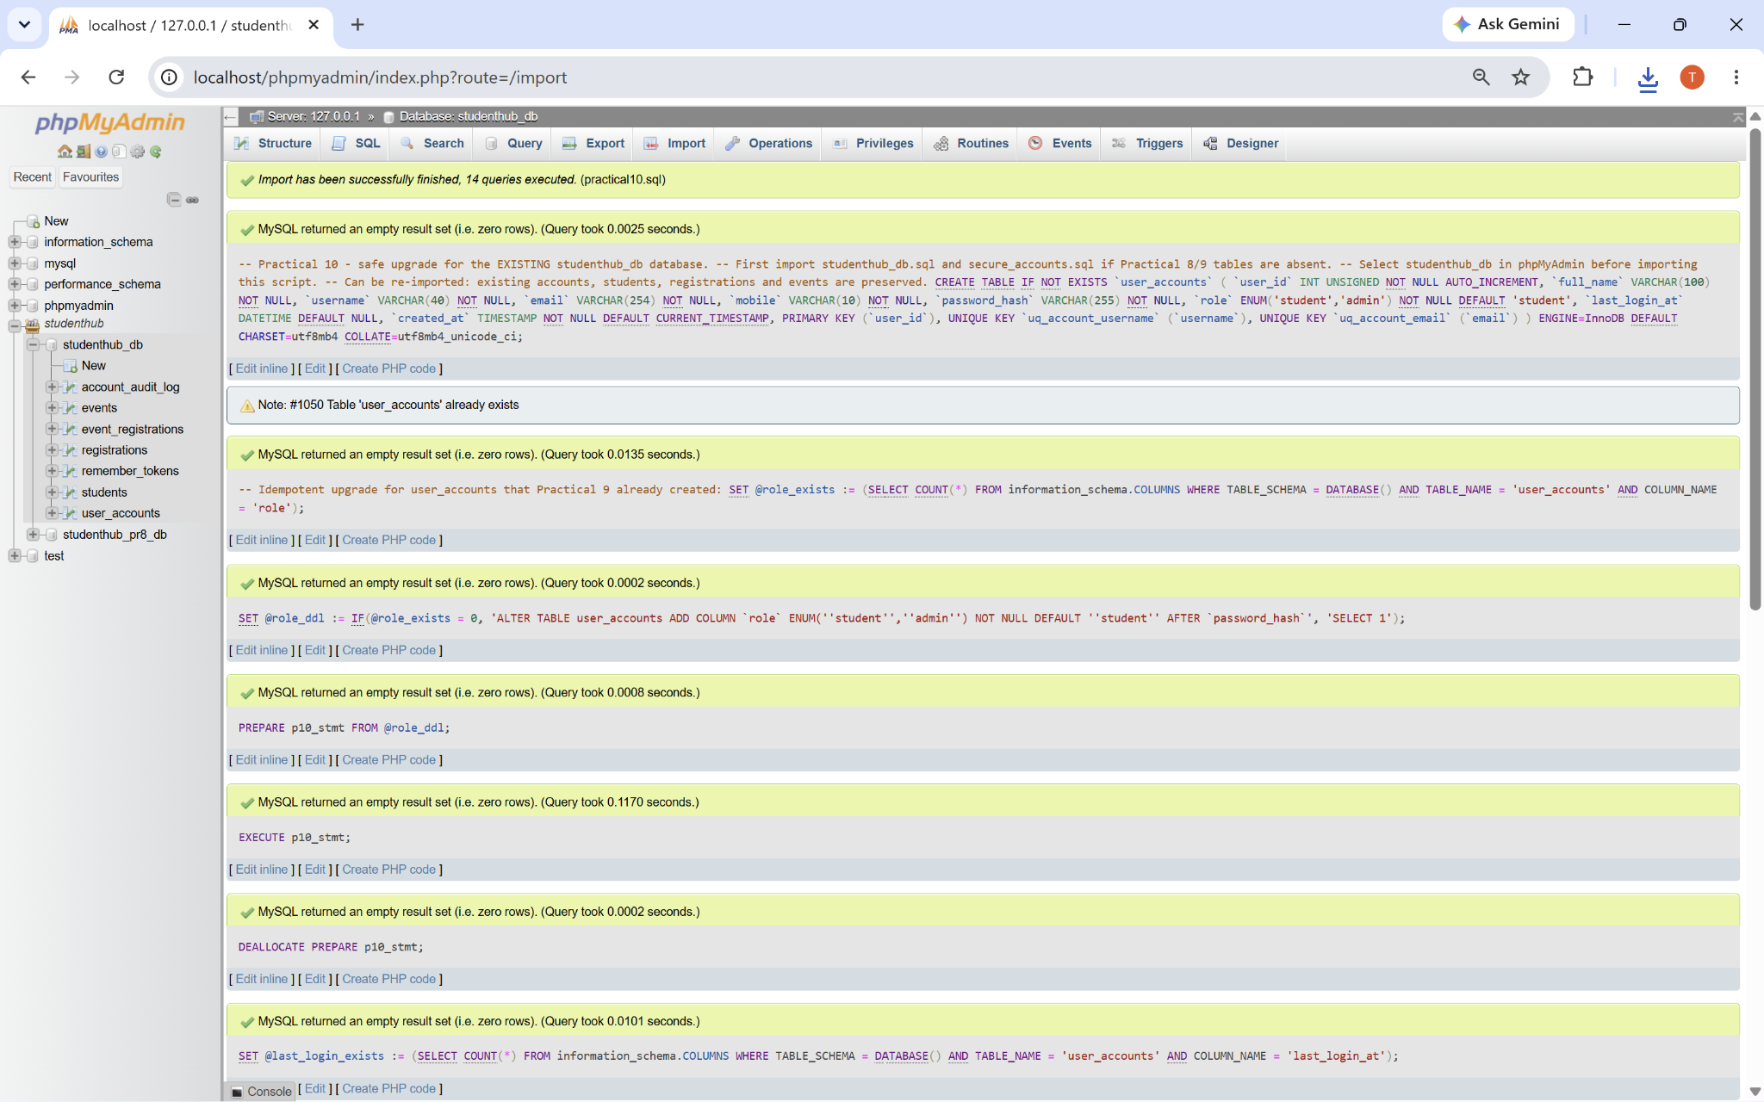
Figure 2: Practical 10 SQL Upgrade - Import Completed

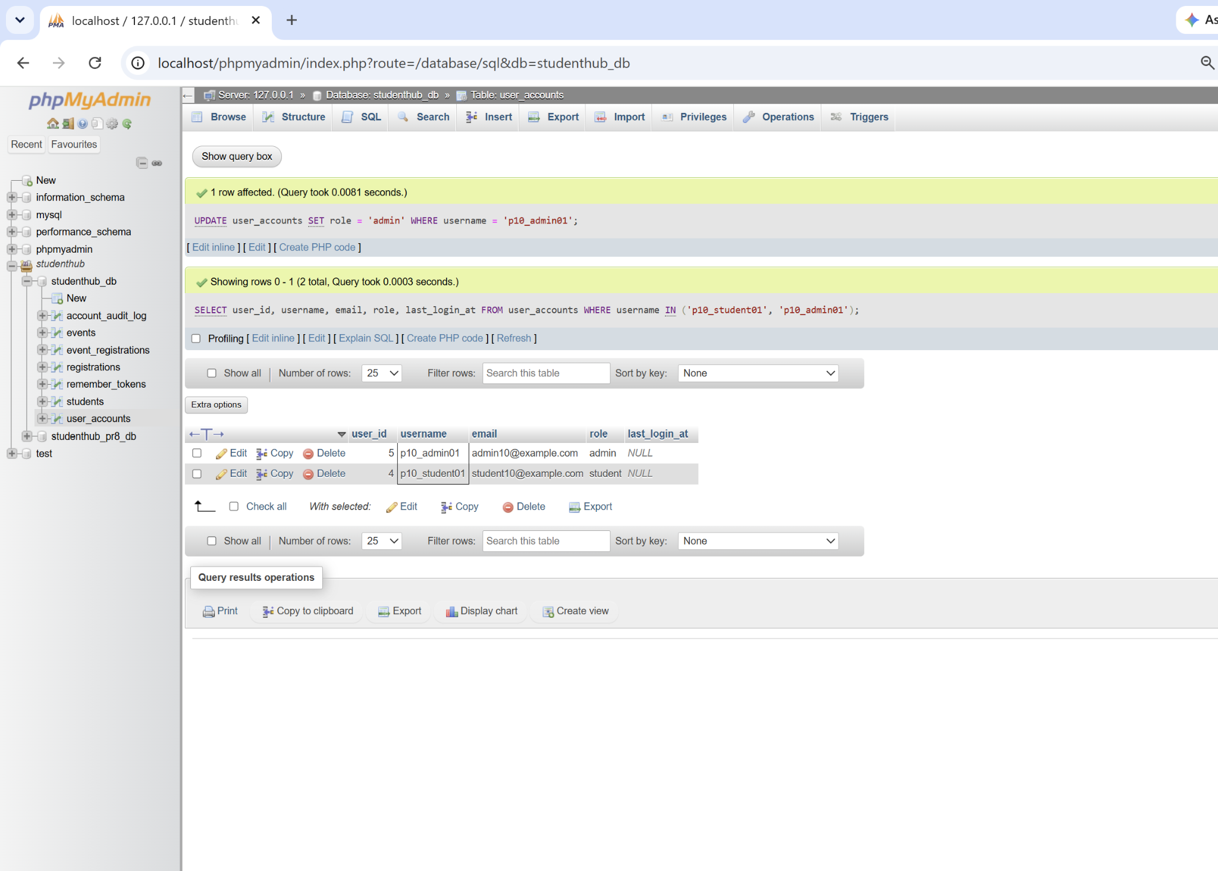
Figure 3: Student and Admin Roles Configured in MySQL
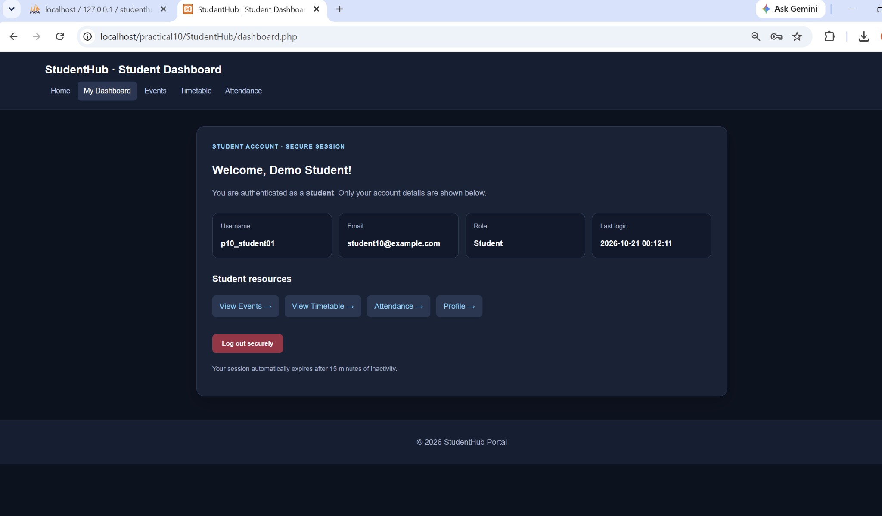
Figure 4: Student Login Success - Student Dashboard

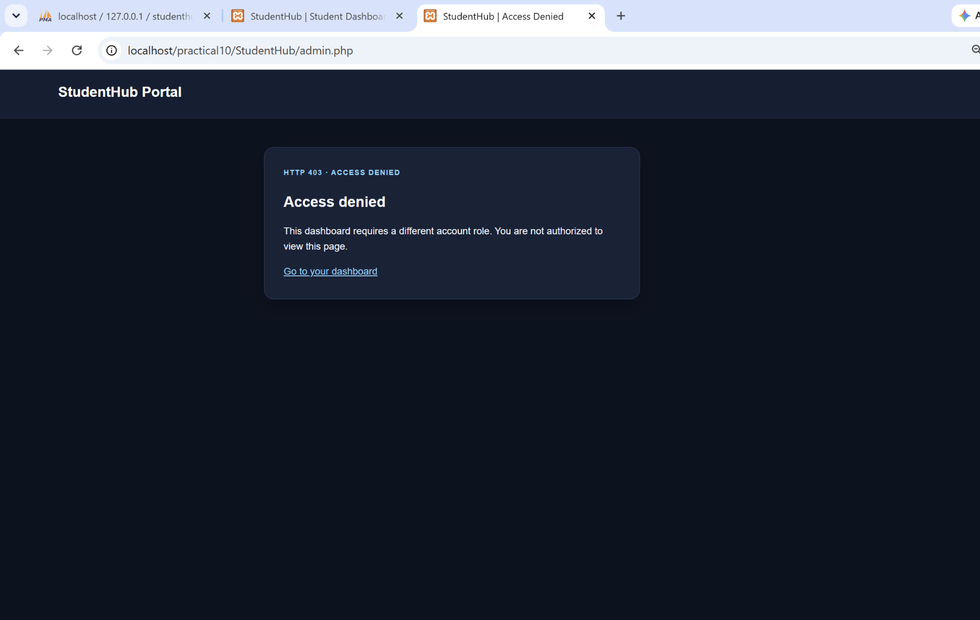
Figure 5: Student Blocked from Admin Page (HTTP 403)
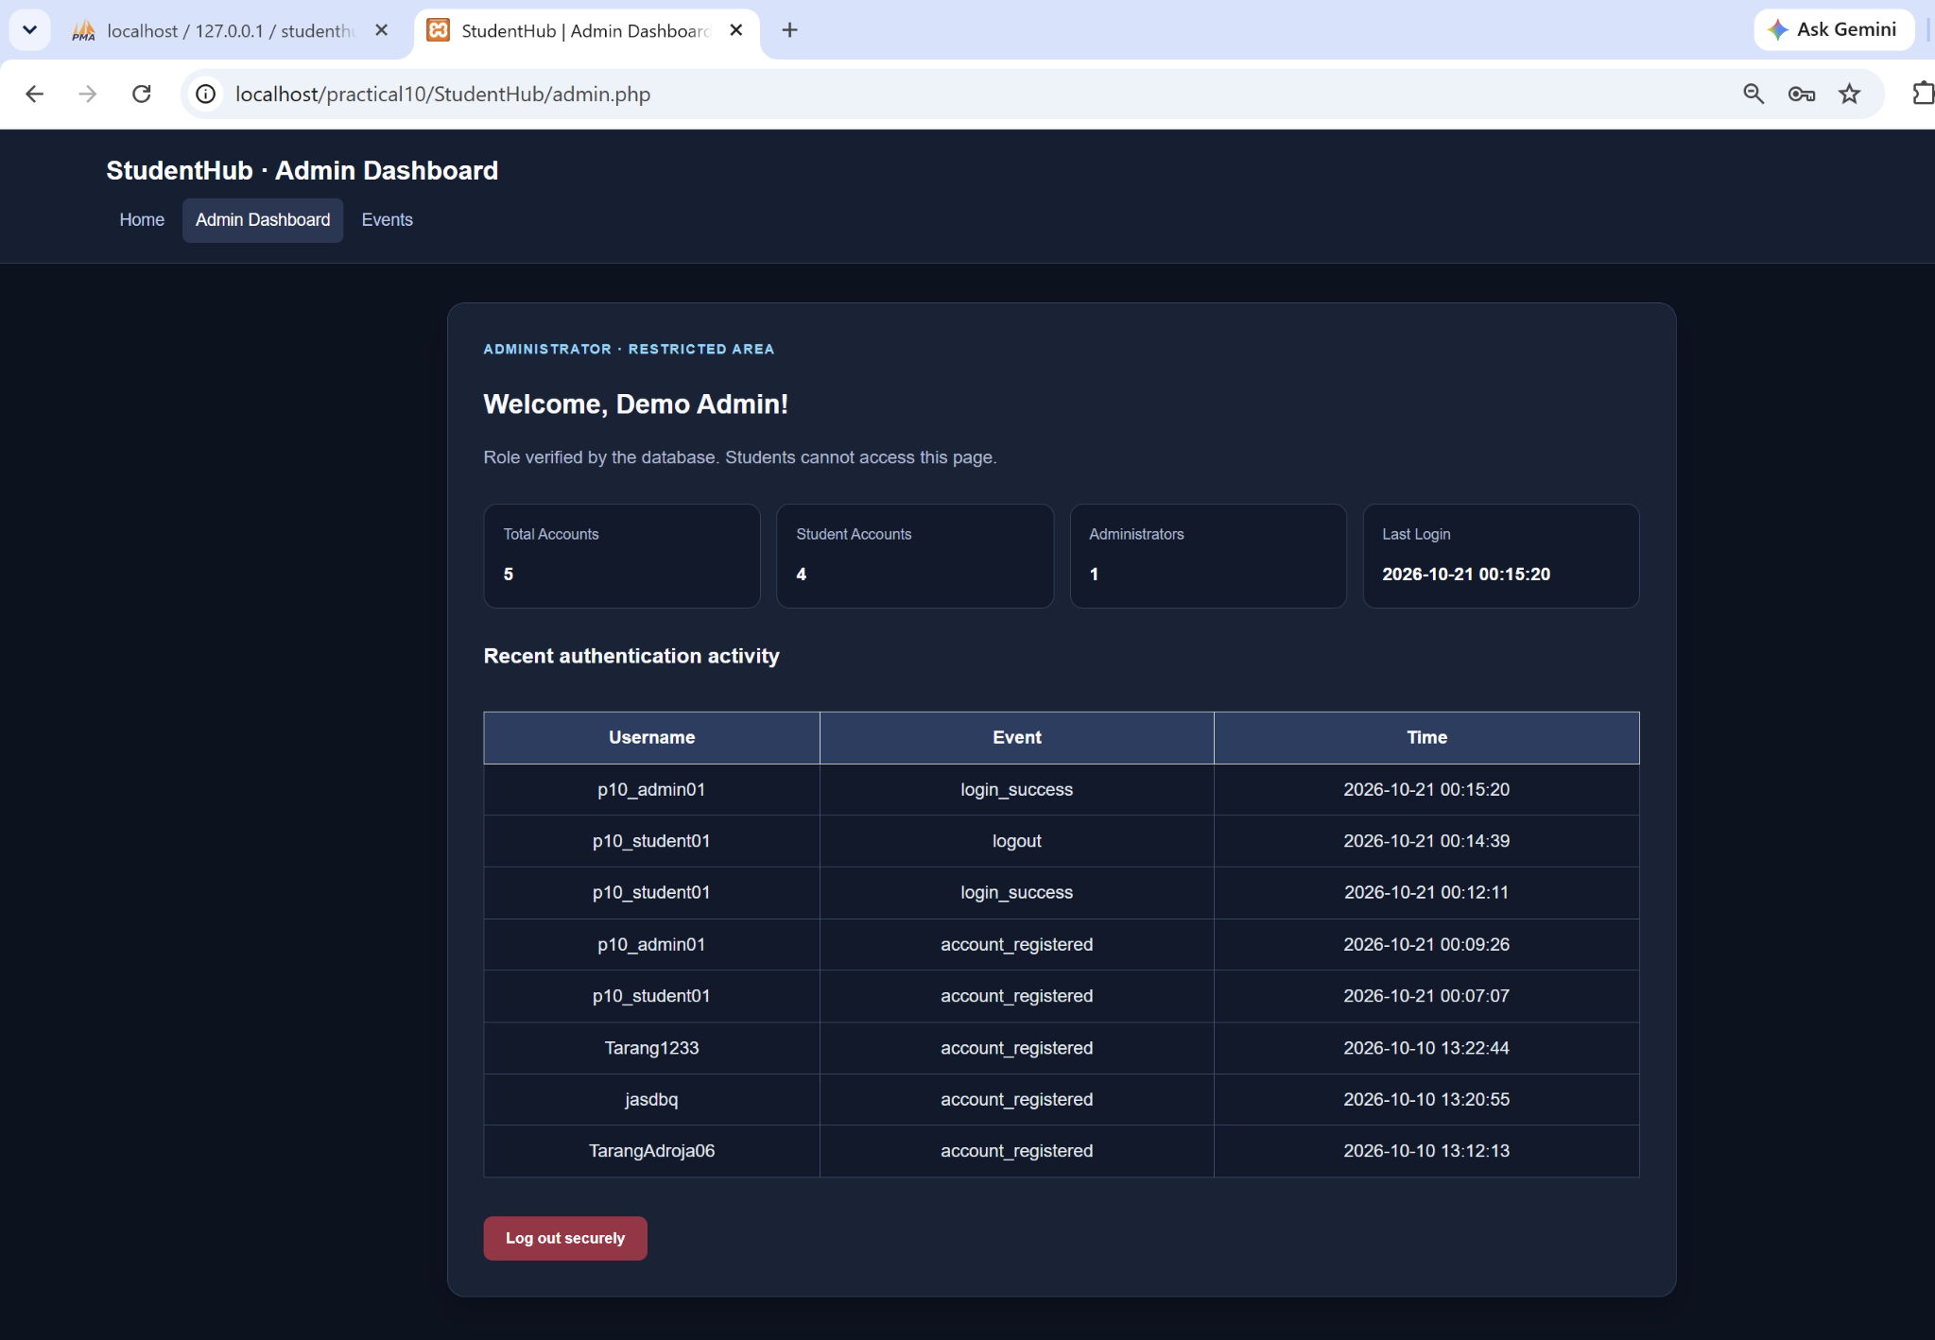
Figure 6: Admin Login Success - Restricted Dashboard and Activity

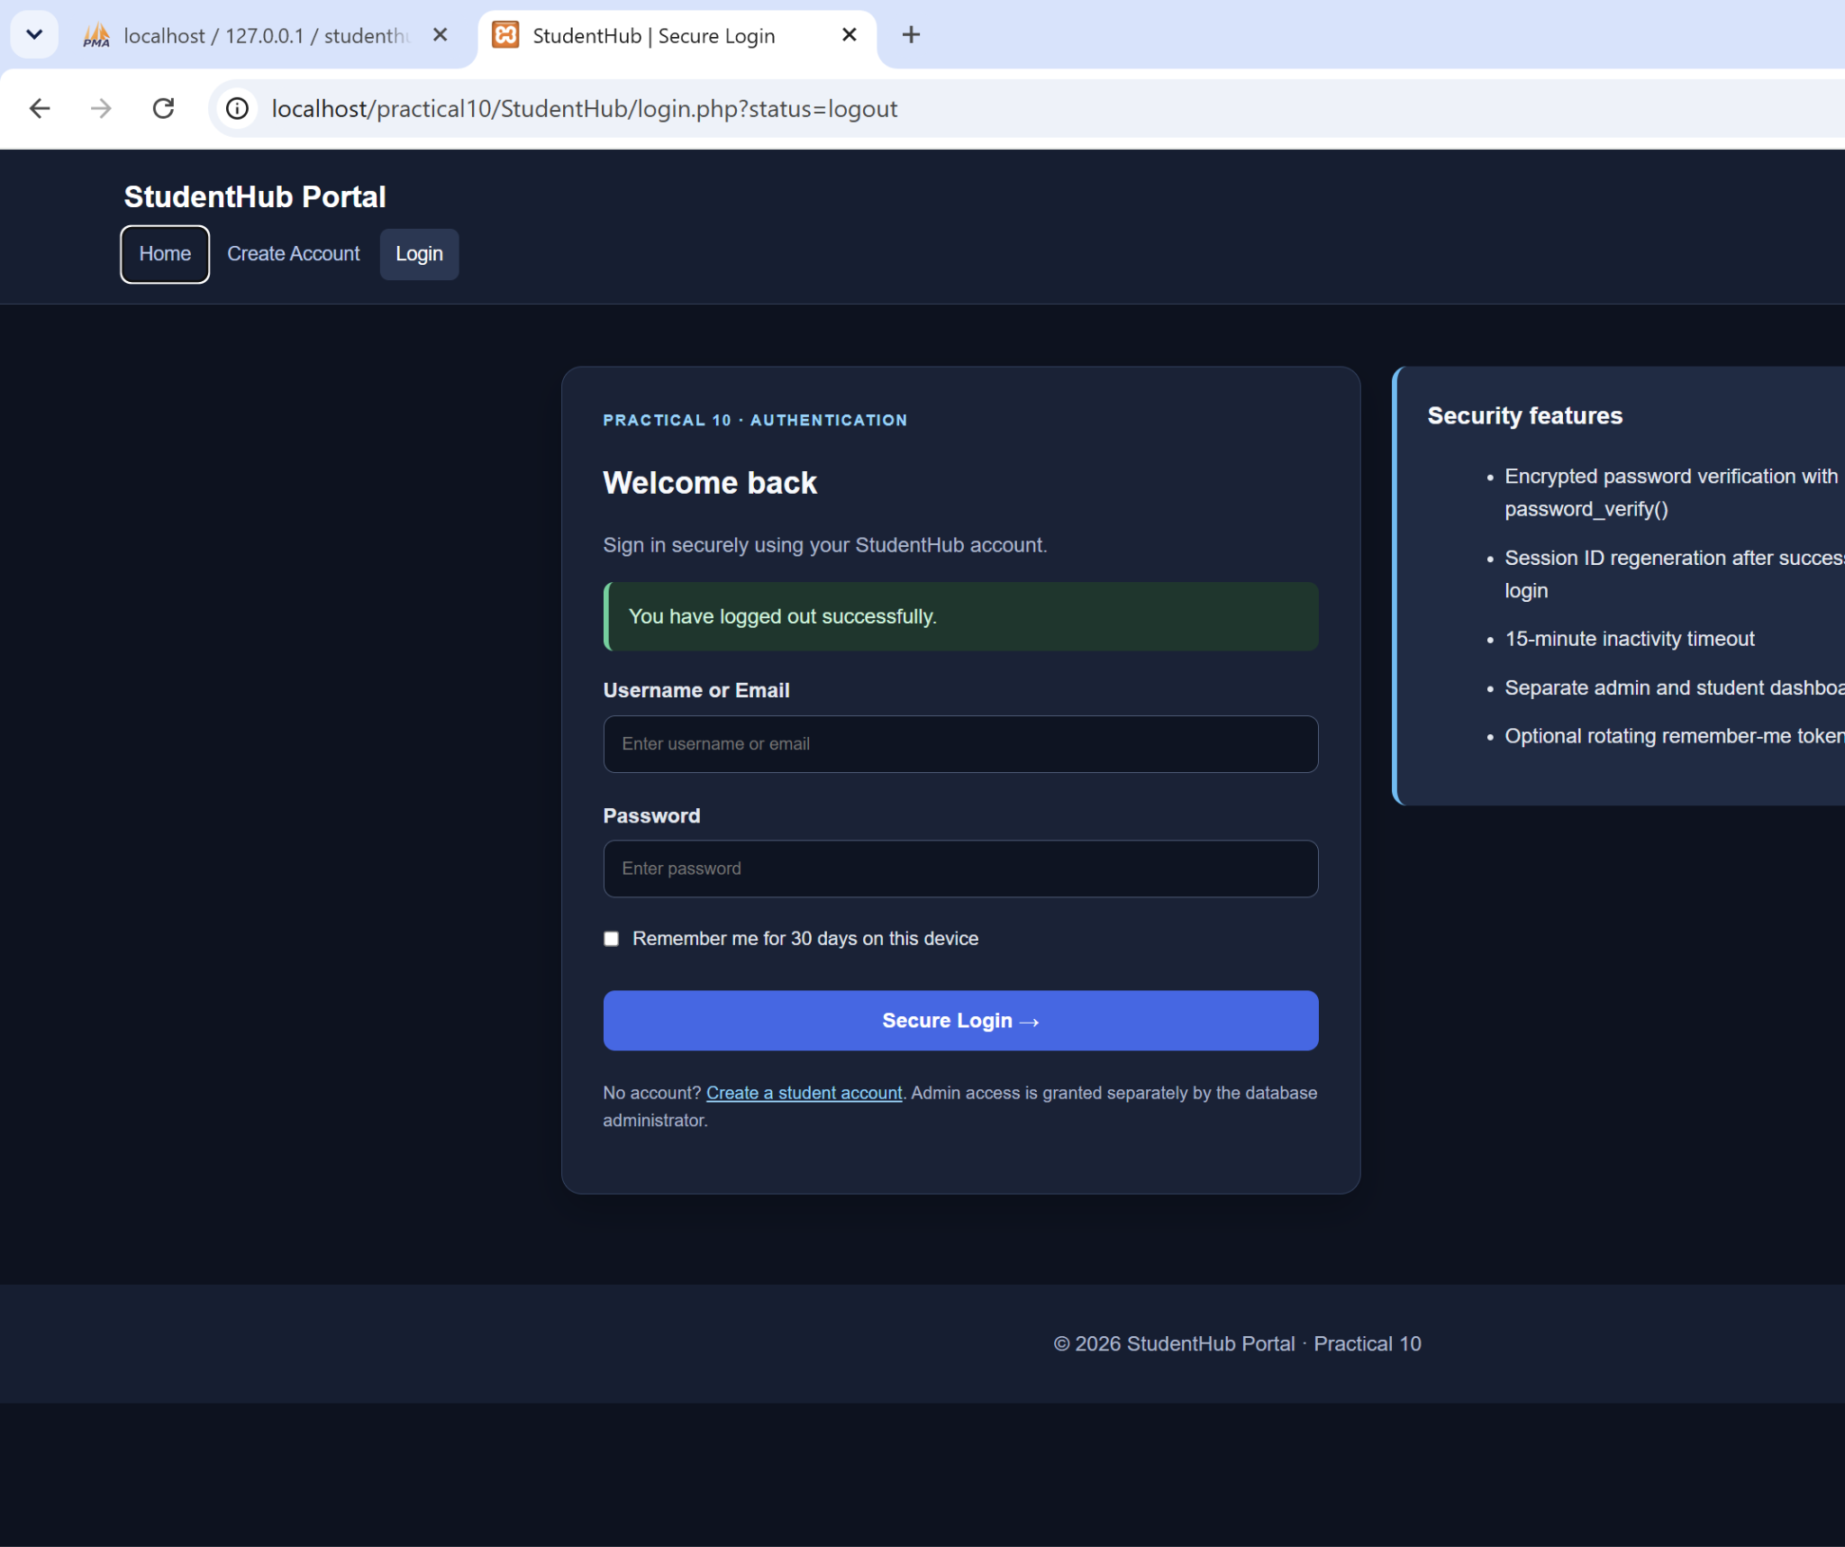
Figure 7: Secure Logout - Confirmation on Login Page
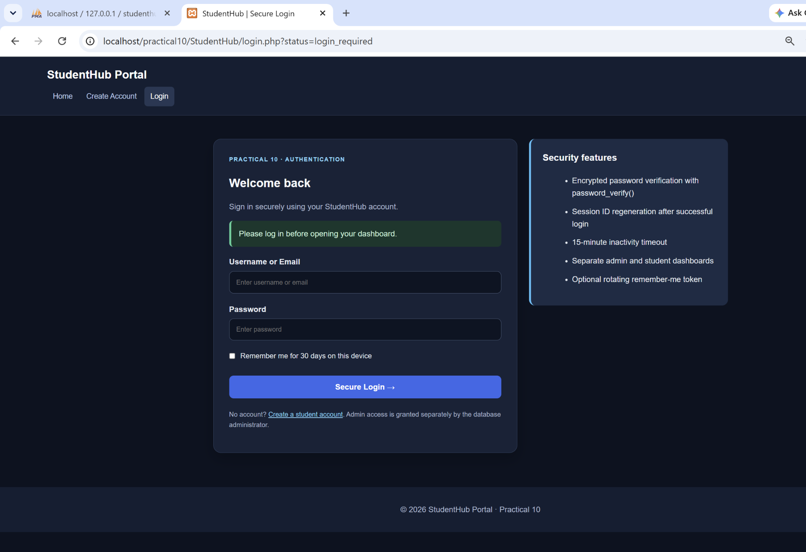
Figure 8: Dashboard Access After Logout - Login Required

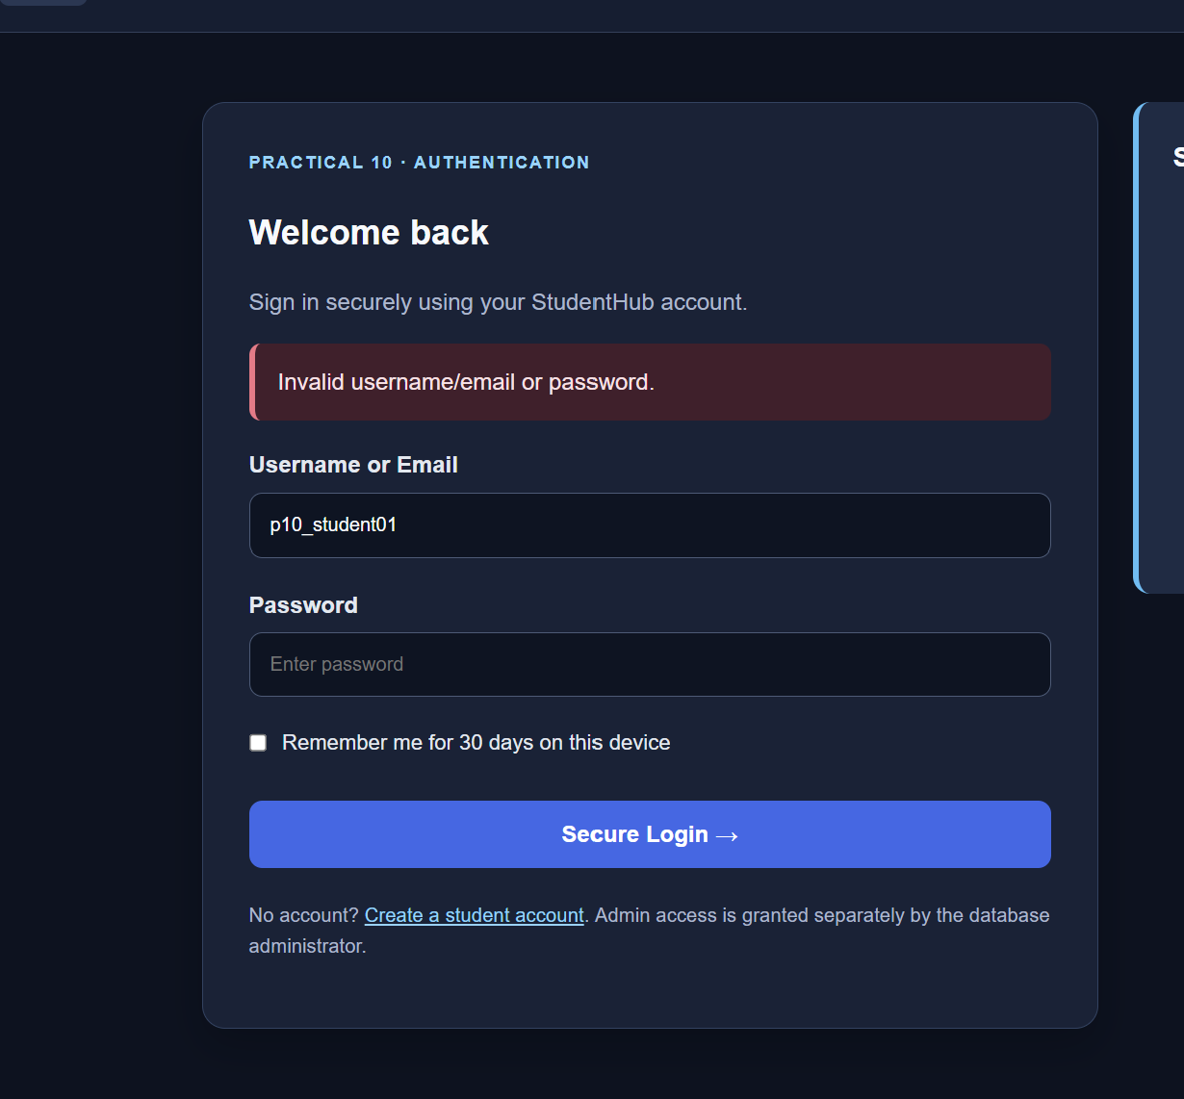
Figure 9: Failed Login - Incorrect Password Rejected
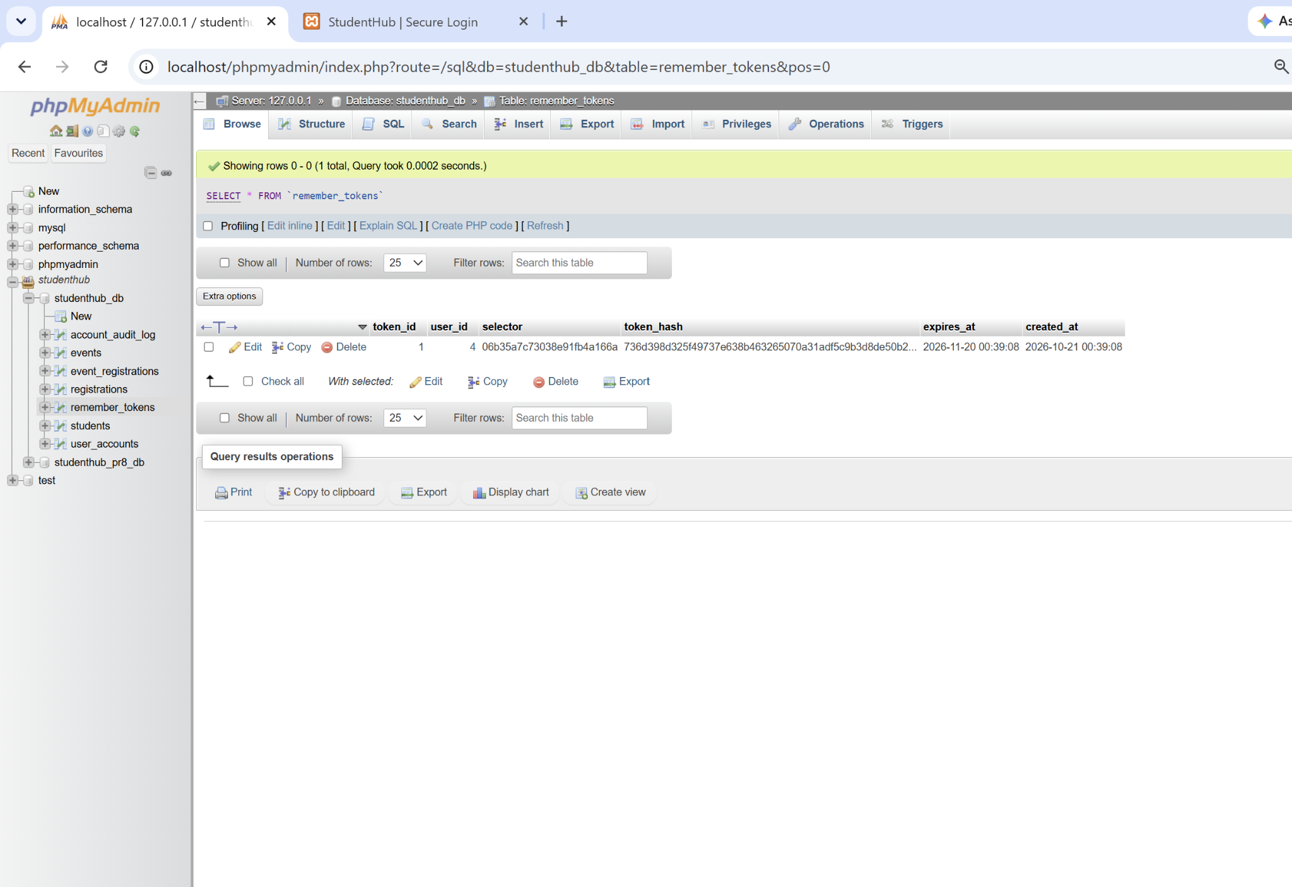
Figure 10: Remember-Me Token Hash Saved in MySQL

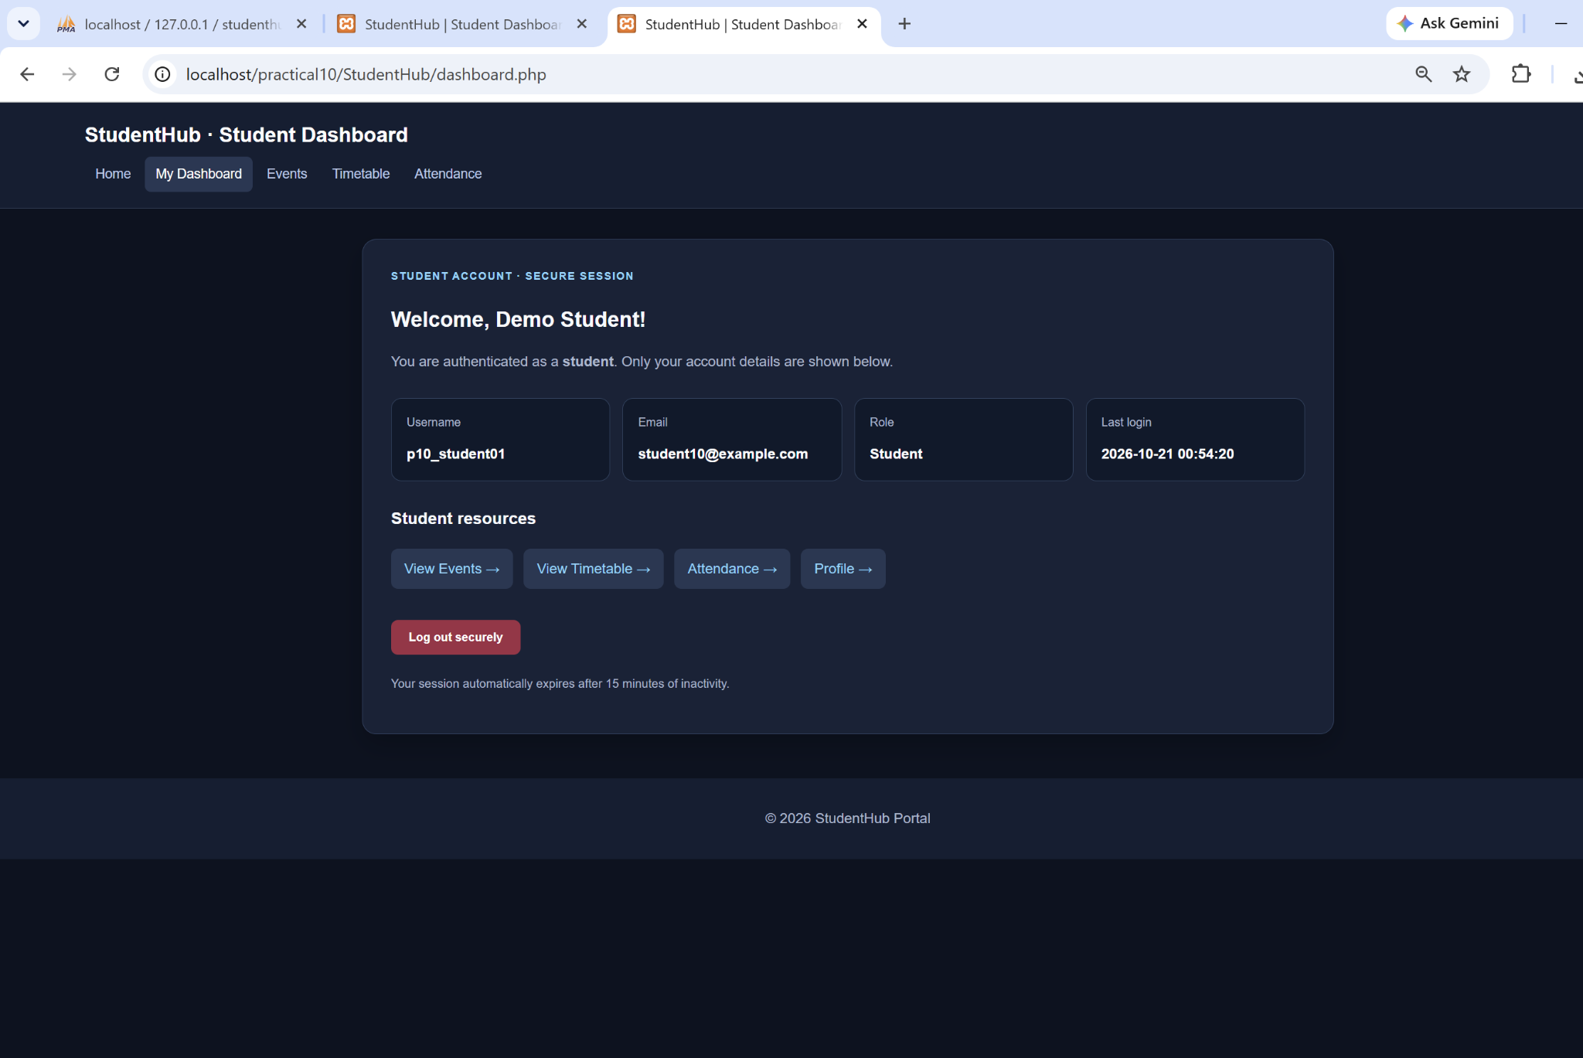
Figure 11: Student Dashboard Reopened After Session-Cookie Removal
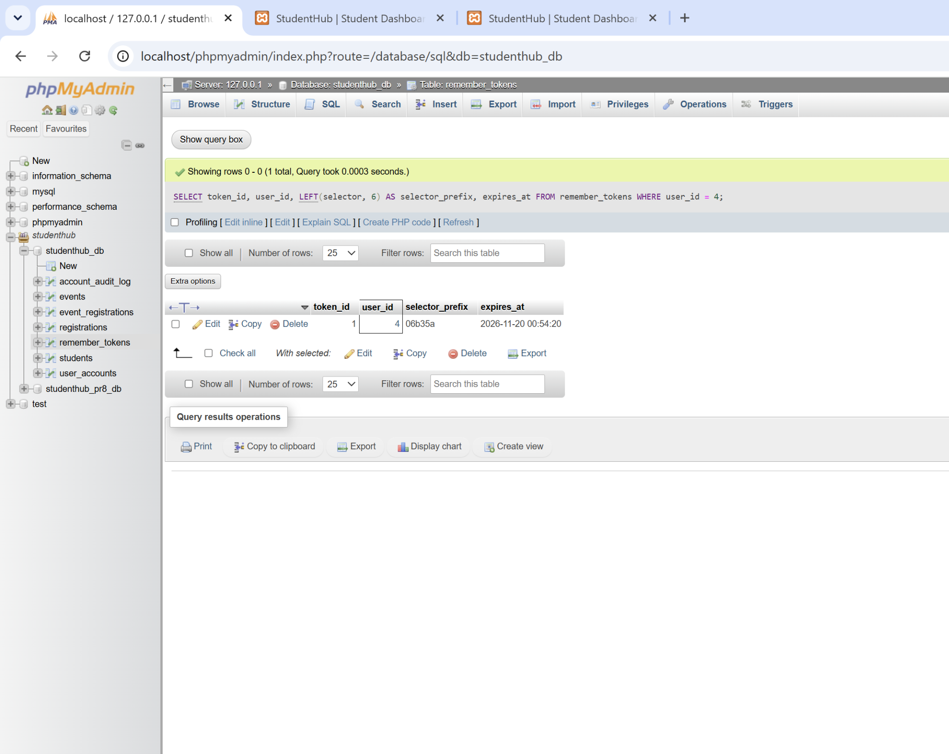
Figure 12: Remember-Me Token Record Checked After Re-entry

A. GitHub Repository Link:
https://github.com/adrojatarang8-art/StudentHub
B. Challenges Faced:
• I first resolved a 404 error by using the correct practical10/StudentHub project folder URL.
• I imported the Practical 10 SQL changes into the existing studenthub_db without deleting earlier records.
• I created separate student and administrator test accounts and assigned the administrator role through MySQL.
• I verified that student users cannot access the admin dashboard and that logged-out users must sign in again.
• I inspected Remember-Me token records and learned that a stable selector alone does not prove or disprove token-hash rotation.
C. Learning Outcome:-
I learned to create a secure PHP login system using password_verify(), session_regenerate_id(), role-based dashboard protection and logout. I tested failed login attempts, admin/student redirection, and access restrictions. I also learned how secure Remember-Me tokens are stored as hashes in MySQL and how to inspect authentication records in phpMyAdmin.
Verification Note:
The 15-minute session timeout is present in the code but its timed browser test was not documented. The token record and dashboard re-entry were shown; token-hash rotation and revocation after final logout were not verified with paired database screenshots.
Faculty Remarks:

